Topic 2 : External Interupts

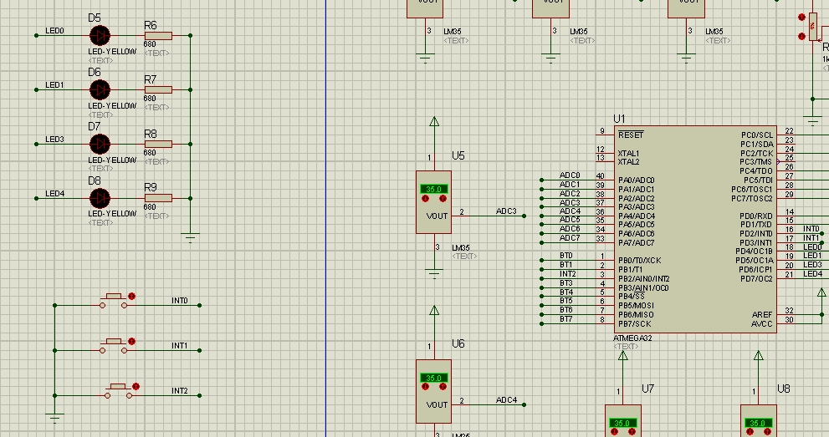

Problem 1 : Write the C program using external interrupt ISR to scan INT0,INT and INT2 when INT-X is pressed, toggle The aprropriate LED0,LED1and LED3 .

Problem 2 : Convert the C Code in Problem 1 into Assembly Code